STOCK PRICE PREDICTOR

*Using Long-Short Term Memory Networks*

*A dissertation report submitted in fulfilment of the requirements*

*for the degree of Bachelor of Technology*

*by*

PRIYANKA MEENA (2016UCP1437)

GORLA JAHNAVI (2016UCP)



DEPARTMENT OF COMPUTER SCIENCE & ENGINEERING

MALAVIYA NATIONAL INSTITUTE OF TECHNOLOGY

DECEMBER 2019

**Abstract**

**Name of the student:** PRIYANKA MEENA (2016UCP1437)

GORLA JAHNAVI (2016UCP)

**Degree for which submitted:** B.Tech.

**Department:** Computer Science and Engineering

**Thesis title:** STOCK PRICE PREDICTOR

**Thesis supervisor:**

**Month and year of thesis submission: DECEMBER, 2019**

*Abstract*

**Acknowledgements**

Student Name Student Name

(ID) (ID)

**Contents**

Certificate . . . . . . . . . . . . . . . . . . . . . . . . . . . . . . . . . . . . . . . . . . . . . . . . . . . . . . . . . . . . . . . . . . . .i

Abstract . . . . . . . . . . . . . . . . . . . . . . . . . . . . . . . . . . . . . . . . . . . . . . . . . . . . . . . . .. . . . . . . . . . . . . ii

Acknowledgements . . . . . . . . . . . . . . . . . . . . . . . . . . . . . . . . . . . . . . . . . . . . . . . .. . . . . . . . . . . . .iii

List of Figures . . . . . . . . . . . . . . . . . . . . . . . . . . . . . . . . . . . . . . . . . . . . . . . . . . . .. . . . . . . . . . . . vii

List of Tables. . . . . . . . . . . . . . . . . . . . . . . . . . . . . . . . . . . . . . . . . . . . . . . . . . . . .. . . . . . . . . . . viii

1. Introduction . . . . . . . . . . . . . . . . . . . . . . . . . . . . . . . . . . . . . . . . . . . . . . . . . . . .. . . . . . . . . . . . . 1

2. Important Terms and Concepts . . . . . . . . . . . . . . . . . . . . . . . . . . . . . . . . . . . . . . . . . .. . . . . . . 3

3. Proposed Method . . . . . . . . . . . . . . . . . . . . . . . . . . . . . . . . . . . . . . . . . . . . . . . . . . . . . . . . . . . 28

4. Experimental Results. . . . . . . . . . . . . . . . . . . . . . . . . . . . . . . . . . . . . . . . . . . . . . . . . . . . . . . . . 35

5. Conclusion. . . . . . . . . . . . . . . . . . . . . . . . . . . . . . . . . . . . . . . . . . . . . . . . . . . . . . . . . . . . . . . . . 39

References . . . . . . . . . . . . . . . . . . . . . . . . . . . . . . . . . . . . . . . . . . . . . . . . . . . . . . . . . . . . . . . . . . 40

**List of Figures**

1. Selective search . . . . . . . . . . . . . . . . . . . . . . . . . . . . . . . . . . . . . . . . . . . . . . . . . . . . . . . . . . . . .10

2. Fast RCNN architecture . . . . . . . . . . . . . . . . . . . . . . . . . . . . . . . . . . . . . . . . . . . . . . . . . . . . . 12

**List of Tables**

Table 1. Table Caption . . . . . . . . . . . . . . . . . . . . . . . . . . . . . . . . . . . . . . . . . . . . . . . . . . . . . . . . . . . 35

### Project Overview

Investment firms, hedge funds and even individuals have been using financial models to better understand market behavior and make profitable investments and trades. A wealth of information is available in the form of historical stock prices and company performance data, suitable for machine learning algorithms to process.

Can we actually predict stock prices with machine learning? Investors make educated guesses by analyzing data. They'll read the news, study the company history, industry trends and other lots of data points that go into making a prediction. The prevailing theories is that stock prices are totally random and unpredictable but that raises the question why top firms like Morgan Stanley and Citigroup hire quantitative analysts to build predictive models. We have this idea of a trading floor being filled with adrenaline infuse men with loose ties running around yelling something into a phone but these days they're more likely to see rows of machine learning experts quietly sitting in front of computer screens. In fact about 70% of all orders on Wall Street are now placed by software, we're now living in the age of the algorithm.

This project seeks to utilize Deep Learning models, Long-Short Term Memory (LSTM) Neural Network algorithm, to predict stock prices. For data with timeframes recurrent neural networks (RNNs) come in handy but recent researches have shown that LSTM, networks are the most popular and useful variants of RNNs.

I will use Keras to build a LSTM to predict stock prices using historical closing price and trading volume and visualize both the predicted price values over time and the optimal parameters for the model.

### Problem Statement

The challenge of this project is to accurately predict the future closing value of a given stock across a given period of time in the future. For this project I will use a **Long Short**

**Term Memory networks**1 – usually just called “LSTMs” to predict the closing price of the

**S&P 500**2 using a dataset of past prices

#### GOALS

1. Explore stock prices.
2. Implement basic model using linear regression.
3. Implement LSTM using keras library.
4. Compare the results and submit the report.

### Metrics

For this project measure of performance will be using the Mean Squared Error (MSE) and Root Mean Squared Error (RMSE) calculated as the difference between predicted and actual values of the target stock at adjusted close price and the delta between the performance of the benchmark model (Linear Regression) and our primary model (Deep Learning).

# ANALYSIS

### Data Exploration

The data used in this project is of the **Alphabet Inc**3 from **January 1, 2005 to June 20, 2017**, this is a series of data points indexed in time order or a time series. My goal was to predict the closing price for any given date after training. For ease of reproducibility and reusability, all data was pulled from the **Google Finance Python API4**.

The prediction has to be made for Closing (Adjusted closing) price of the data. Since Google Finance already **adjusts the closing prices for us5**, we just need to make prediction for “CLOSE” price.

The dataset is of following form :

|  |  |  |  |  |  |
| --- | --- | --- | --- | --- | --- |
| **Date** | **Open** | **High** | **Low** | **Close** | **Volume** |
| 30-Jun-17 | 943.99 | 945.00 | 929.61 | 929.68 | 2287662 |
| 29-Jun-17 | 951.35 | 951.66 | 929.60 | 937.82 | 3206674 |
| 28-Jun-17 | 950.66 | 963.24 | 936.16 | 961.01 | 2745568 |

*Table: The whole data can be found out in ‘Google.csv’ in the project root folder6*

Note: I did not observe any abnormality in datasets, i.e, no feature is empty and does not contains any incorrect value as negative values.

3 [Alphabet Inc](https://www.google.com/finance/historical?q=NASDAQ%3AGOOGL&amp;startdate=2005-01-01&amp;enddate=June%2030%2C%202017&amp;num=200&amp;ei=KKltWZHCBNWPuQS9147YBw)

4 [Google Finance python api](https://pypi.python.org/pypi/googlefinance)

5 [adjusts the closing prices for us](https://groups.google.com/forum/%23!topic/google-finance/GWPc-8COV3I)

6 [Google.csv](https://github.com/Rajat-dhyani/Stock-Price-Predictor/google.csv)

The mean, standard deviation, maximum and minimum of the data was found to be following:

|  |  |  |  |  |  |
| --- | --- | --- | --- | --- | --- |
| **Feature** | **Open** | **High** | **Low** | **Close** | **Volume** |
| Mean | 382.5141 | 385.8720 | 378.7371 | 382.3502 | 4205707.8896 |
| Std | 213.4865 | 214.6022 | 212.08010 | 213.4359 | 3877483.0077 |
| Max | 1005.49 | 1008.61 | 1008.61 | 1004.28 | 41182889 |
| Min | 87.74 | 89.29 | 86.37 | 87.58 | 521141 |

We can infer from this dataset that date, high and low values are not important features of the data. As it does not matter at what was the highest prices of the stock for a particular day or what was the lowest trading prices. What matters is the opening price of the stock and closing prices of the stock. If at the end of the day we have higher closing prices than the opening prices that we have some profit otherwise we saw losses. Also volume of share is important as a rising market should see rising volume, i.e, increasing price and decreasing volume show lack of interest, and this is a warning of a potential reversal. A price drop (or rise) on large volume is a stronger signal that something in the stock has fundamentally changed.

Therefore i have removed Date, High and low features from data set at preprocessing step. The mean, standard deviation, maximum and minimum of the preprocessed data was found to be following:

|  |  |  |  |  |
| --- | --- | --- | --- | --- |
|  | **Mean** | **Std** | **Max** | **Min** |
| **Open** | 0.3212 | 0.23261 | 1.0 | 0.0 |
| **Close** | 0.3215 | 0.2328 | 1.0 | 0.0 |
| **Volume** | 0.09061 | 0.0953 | 1.0 | 0.0 |

### Exploratory Visualization

To visualize the data i have used **matplotlib7** library. I have plotted Closing stock price of the data with the no of items( no of days) available.

Following is the snapshot of the plotted data :

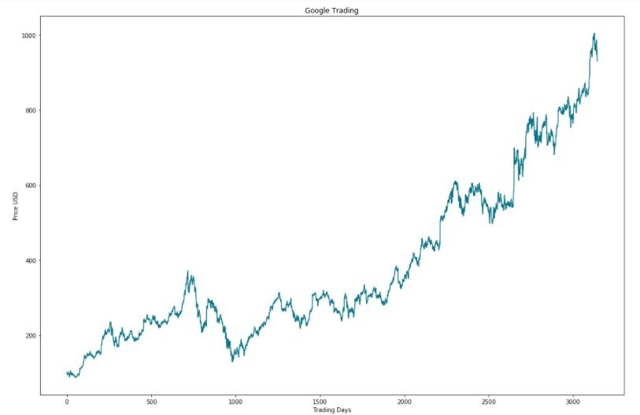

*X-axis: Represents Tradings Days*

*Y-axis: Represents Closing Price In USD*

Through this data we can see a continuous growth in Alphabet Inc. The major fall in the prices between 600-1000 might be because of the Global Financial Crisis of 2008-2009.

7 [Matplotlib](https://matplotlib.org/)

### Algorithms and Techniques

The goal of this project was to study time-series data and explore as many options as possible to accurately predict the Stock Price. Through my research i came to know about **Recurrent Neural Nets (RNN)8** which are used specifically for sequence and pattern learning. As they are networks with loops in them, allowing information to persist and thus ability to memorise the data accurately. But Recurrent Neural Nets have vanishing Gradient descent problem which does not allow it to learn from past data as was expected. The remedy of this problem was solved in **Long-Short Term Memory Networks9**, usually referred as LSTMs. These are a special kind of RNN, capable of learning long-term dependencies.

In addition to adjusting the architecture of the Neural Network, the following full set of parameters can be tuned to optimize the prediction model:

* Input Parameters
  + Preprocessing and Normalization (see Data Preprocessing Section)
* Neural Network Architecture
  + Number of Layers (how many layers of nodes in the model; used 3)
  + Number of Nodes (how many nodes per layer; tested 1,3,8, 16, 32, 64, 100,128)
* Training Parameters
  + Training / Test Split (how much of dataset to train versus test model on; kept constant at 82.95% and 17.05% for benchmarks and lstm model)
  + Validation Sets (kept constant at 0.05% of training sets)
  + Batch Size (how many time steps to include during a single training step; kept at 1 for basic lstm model and at 512 for improved lstm model)
  + Optimizer Function (which function to optimize by minimizing error; used “Adam” throughout)
  + Epochs (how many times to run through the training process; kept at 1 for base

8 [Recurrent Neural Network](https://en.wikipedia.org/wiki/Recurrent_neural_network)

9 [Long-Short Term Memory](https://en.wikipedia.org/wiki/Long_short-term_memory)

model and at 20 for improved LSTM)

### Benchmark Model

For this project i have used a Linear Regression model as its primary benchmark. As one of my goals is to understand the relative performance and implementation differences of machine learning versus deep learning models. This Linear Regressor was based on the examples presented in Udacity’s Machine Learning for Trading course and was used for error rate comparison MSE and RMSE utilizing the same dataset as the deep learning models.

Following is the predicted results that i got from my benchmark model :

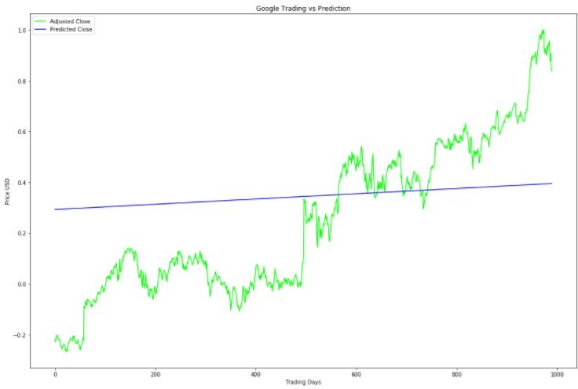

*X-axis: Represents Tradings Days*

*Y-axis: Represents Closing Price In USD Green line: Adjusted Close price Blue Line: Predicted Close price*

**Train Score: 0.1852 MSE (0.4303 RMSE)**

**Test Score: 0.08133781 MSE (0.28519784 RMSE)**

# METHODOLOGY

### Data Preprocessing

Acquiring and preprocessing the data for this project occurs in following sequence, much of which has been modularized into the **preprocess.py** file for importing and use across all notebooks:

* Request the data from the Google Finance Python API and save it in **google.csv** file in the following format.

|  |  |  |  |  |  |
| --- | --- | --- | --- | --- | --- |
| **Date** | **Open** | **High** | **Low** | **Close** | **Volume** |
| 30-Jun-17 | 943.99 | 945.00 | 929.61 | 929.68 | 2287662 |
| 29-Jun-17 | 951.35 | 951.66 | 929.60 | 937.82 | 3206674 |
| 28-Jun-17 | 950.66 | 963.24 | 936.16 | 961.01 | 2745568 |

* Remove unimportant features(date, high and low) from the acquired data and reversed the order of data, i.e., from january 03, 2005 to june 30, 2005

|  |  |  |  |
| --- | --- | --- | --- |
| **Item** | **Open** | **Close** | **Volume** |
| 0 | 98.80 | 101.46 | 15860692 |
| 1 | 100.77 | 97.35 | 13762396 |

|  |  |  |  |
| --- | --- | --- | --- |
| 2 | 96.82 | 96.85 | 8239545 |
| 3 | 97.72 | 94.37 | 10389803 |

* Normalised the data using **MinMaxScaler** helper function from Scikit-Learn.

|  |  |  |  |
| --- | --- | --- | --- |
| **Item** | **Open** | **Close** | **Volume** |
| 0 | 0.012051 | 0.015141 | 0.377248 |
| 1 | 0.014198 | 0.010658 | 0.325644 |
| 2 | 0.009894 | 0.010112 | 0.189820 |
| 3 | 0.010874 | 0.007407 | 0.242701 |

* Stored the normalised data in **google_preprocessed.csv** file for future reusability.
* Splitted the dataset into the training (68.53%) and test (31.47%) datasets for linear regression model. The split was of following shape :

x_train (2155, 1)

y_train (2155, 1)

x_test (990, 1)

y_test (990, 1)

* Splitted the dataset into the training (82.95%) and test (17.05%) datasets for LSTM model. The Split was of following shape:

x_train (2589, 50, 3)

y_train (2589,)

x_test (446, 50, 3)

y_test (446,)

### Implementation

Once the data has been downloaded and preprocessed, the implementation process occurs consistently through all three models as follow:

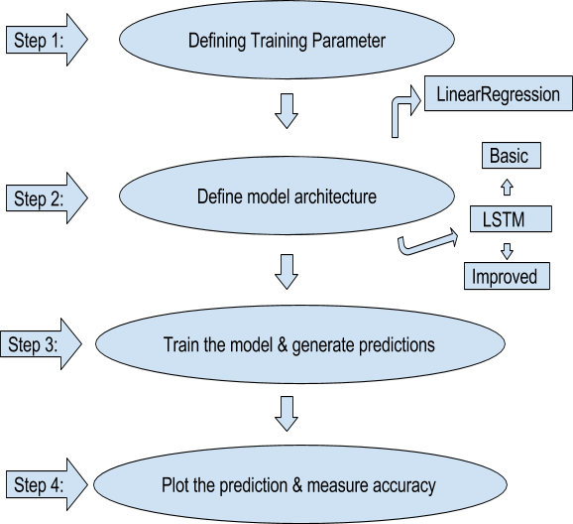

I have thoroughly specified all the steps to build, train and test model and its predictions in the notebook itself.

##### Some code implementation insight:

**Benchmark model :**

**Step 1 :** Split into train and test model :

Here I am calling a function defined in **‘stock_data.py’** which splits the data for linear regression model. The function is as follows :

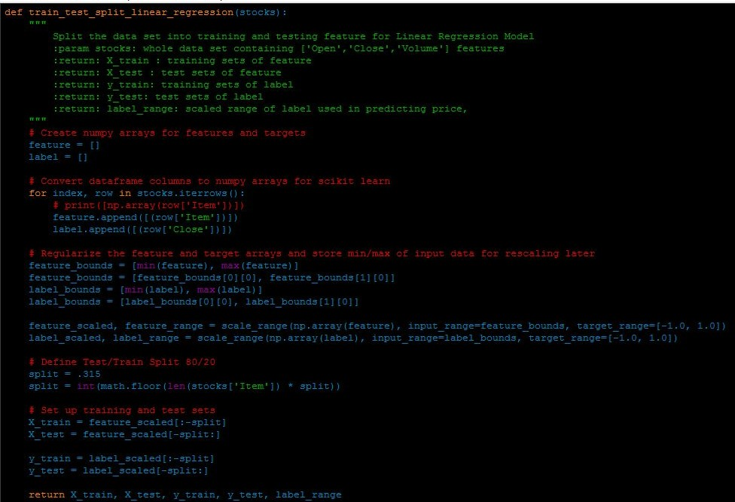

**Step 2:** In this step model is built using **scikit-learn linear_model10** library.



Here I am calling a function defined in **‘LinearRegressionModel.py**’ which builds the model for the project. The screenshot of the function is as follows:

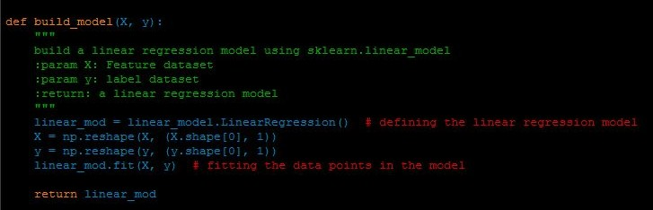

**Step 3:** Now it’s time to predict the prices for given test datasets.



The screenshot of the function is as follows, it is defined in **‘LinearRegressionModel.py**’:

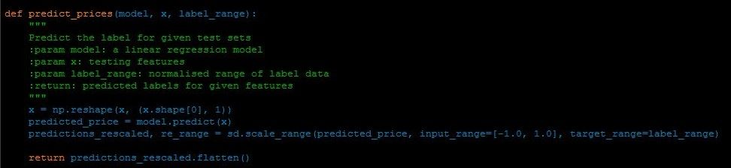

10 [Linear Model](http://scikit-learn.org/0.17/modules/linear_model.html)

**Step 4:** Finally calculate the test score and plot the results of benchmark model.

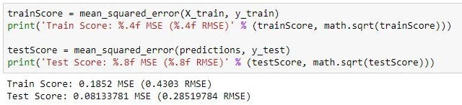

**Improved LSTM model :**

**Step 1 :** Split into train and test model :

Note : The same set of training and testing data is used for improved LSTM as is used with basic LSTM.

**Step 2 :** Build an improved LSTM model :

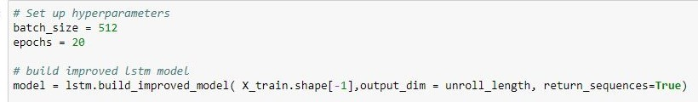

Here I am calling a function defined in **‘lstm.py**’ which builds the improved lstm model for the project. The screenshot of the function is as follows:

NOTE: The function uses **keras Long short term memory11**

model.

I have increased the batch_size to 512 from 1 Epochs from 1 to 20 for my improved LSTM model

library to implement LSTM

Also in the function i have add increased the no of nodes in hidden layer to 128 from 100 and have added a drop out of 0.2 to all the layers.

11 [Long Short Term Memory](https://keras.io/layers/recurrent/)

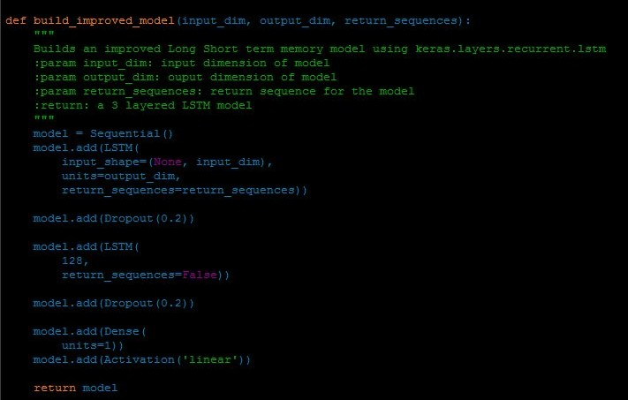

**Step 3:** We now need to train our model.

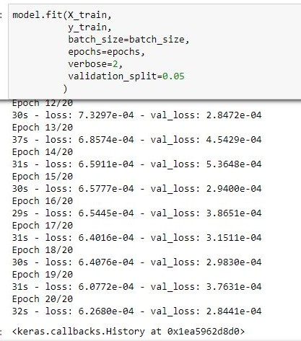

I have used here a built in library function to train the model.

**Step 4:** Now it’s time to predict the prices for given test datasets.



I have used a built-in function to predict the outcomes of the model.

**Step 5:** Finally calculate the test score and plot the results of improved LSTM

model.

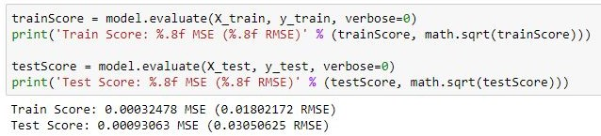

### Refinement

For this project i have worked on fine tuning parameters of LSTM to get better predictions. I did the improvement by testing and analysing each parameter and then selecting the final value for each of them.

To improve LSTM i have done following:

* Increased the number of hidden node from 100 to 128.
* Added Dropout of 0.2 at each layer of LSTM
* Increased batch size from 1 to 512
* Increased epochs from 1 to 20
* Added verbose = 2
* Made prediction with the batch size

Thus improved my mean squared error, for testing sets, from **0.01153170 MSE** to

##### 0.00093063 MSE.

The predicted plot difference can be seen as follows:

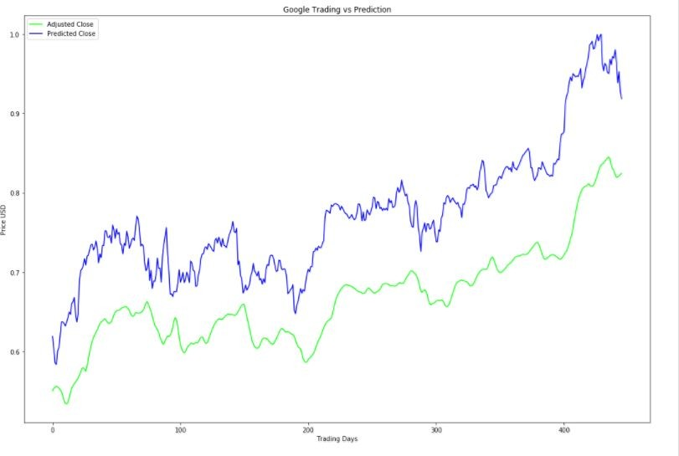

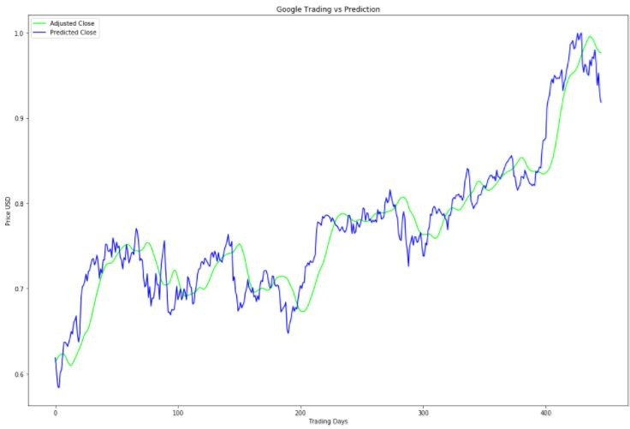*Fig : Plot For Adjusted Close and Predicted Close Prices for basic LSTM model*

*Fig : Plot For Adjusted Close and Predicted Close Prices for improved LSTM model*

Proposal for Predicting Stock Prices using LSTM

**July 16, 2017**

Domain Background

Investment firms, hedge funds and even individuals have been using financial models to better understand market behavior and make profitable investments and trades. A wealth of information is available in the form of historical stock prices and company performance data, suitable for machine learning algorithms to process.

Can we actually predict stock prices with machine learning? Investors make educated guesses by analyzing data. They'll read the news, study the company history, industry trends and other lots of data points that go into making a prediction. The prevailing theories is that stock prices are totally random and unpredictable but that raises the question why top firms like Morgan Stanley and Citigroup hire quantitative analysts to build predictive models. We have this idea of a trading floor being filled with adrenaline infuse men with loose ties running around yelling something into a phone but these days they're more likely to see rows of machine learning experts quietly sitting in front of computer screens. In fact about 70% of all orders on Wall Street are now placed by software, we're now living in the age of the algorithm.



## 2

This project seeks to utilize Deep Learning models, Long-Short Term Memory (LSTM) Neural Network algorithm, to predict stock prices. For data with timeframes recurrent neural networks (RNNs) come in handy but recent researches have shown that LSTM, networks are the most popular and useful variants of RNNs.

I will use Keras to build a LSTM to predict stock prices using historical closing price and trading volume and visualize both the predicted price values over time and the optimal parameters for the model.

# Problem Statement

The challenge of this project is to accurately predict the future closing value of a given stock across a given period of time in the future. In the past few years we've seen lots of academic papers published using neural nets to predict stock prices with varying degrees of success but until recently the ability to build these models has been restricted to academics. Now with libraries like tensor flow anyone can build powerful predictive models trained on masive of datasets. For this project I will use a [Long Short Term Memory networks – usually just called](http://colah.github.io/posts/2015-08-Understanding-LSTMs/) [“LSTMs”](http://colah.github.io/posts/2015-08-Understanding-LSTMs/) to predict the closing price of the [S&P 500](https://en.wikipedia.org/wiki/List_of_S%26P_500_companies) using a dataset of past prices

### Goals

1. Explore stock prices.
2. Implement basic model using linear regression
3. Implement LSTM using keras library.
4. Compare the results and submit the report



3

Datasets and Inputs

I’ll be using the daily prices of the S&P 500 from January 2000 to June 2017, this is a series of data points indexed in time order or a time series. My goal will be to predict the closing price for any given date after training. All of the necessary data for the project will come from Google Finance.

# Solution Statement

For this project according to my research the best possible solution is to utilize a LSTM Neural Net model capable of learning from time series data. This project will be programmed in a Jupyter Notebook (iPython) for ease of reproducibility. Using a Keras implementation of the Tensor Flow library, the solution will utilize a LSTM Neural Net model and will be supported by Pandas DataFrame library for convenient time series data schema.The measures of performance will be based on the predicted stock ticker price in comparison to both the actual price and the benchmark model's predicted price.

# Benchmark Model

For this project i will use a Linear Regression model as its primary benchmark. As one of my goals is to understand the relative performance and implementation differences of machine learning versus deep learning models. This Linear Regressor will be based on the examples presented in Udacity’s Machine Learning for Trading course and will be used for error rate comparison MSE and RMSE utilizing the same dataset as the deep learning models.

# Evaluation Metrics

For this project i will measure performance using the mean squared difference between predicted and actual values of the target stock at adjusted close price and the delta between the



## 4

performance of the benchmark model (Linear Regression) and our primary model (Deep Learning).

# Project Design

This project will be implemented through the Keras/Tensor Flow library using LSTM Neural Networks. Development workflow will follow the below sequence:

### Set Up Infrastructure

* + iPython Notebook
  + Incorporate required Libraries (Keras, Tensor flow, Pandas, Matplotlib, Sklearn, Numpy)
  + Git project organization

### Prepare Dataset

* + Incorporate data of S&P 500 companies
  + Process the requested data into Pandas Dataframe
  + Develop function for normalizing data
  + Dataset will be used with a 80/20 split on training and test data across all models

### Develop Benchmark Model

* + Set up basic Linear Regression model with Scikit-Learn
  + Calibrate parameters

### Develop Basic LSTM Model



5

* + Set up basic LSTM model with Keras utilizing parameters from Benchmark Model

### Improve LSTM Model

* + Develop, document, and compare results using additional labels for the LSMT model

### Document and Visualize Results

* + Plot Actual, Benchmark Predicted Values, and LSTM Predicted Values per time series
  + Analyze and describe results for report.

# NOTE : The actual implementation may vary a little from proposed design as i have not yet implemented the project.

# RESULT

### Model Evaluation and Validation

With each model i have refined and fined tune my predictions and have reduced mean squared error significantly.

* For my first model using linear regression model:
  + **Train Score: 0.1852 MSE (0.4303 RMSE)**
  + **Test Score: 0.08133781 MSE (0.28519784 RMSE)**



*Fig: Plot of Linear Regression Model*

* For my second model using basic Long-Short Term memory model:
  + **Train Score: 0.00089497 MSE (0.02991610 RMSE)**
  + **Test Score: 0.01153170 MSE (0.10738577 RMSE)**



*Fig: Plot of basic Long-Short Term Memory model*

* For my third and final model, using improved Long-Short Term memory model:
  + **Train Score: 0.00032478 MSE (0.01802172 RMSE)**
  + **Test Score: 0.00093063 MSE (0.03050625 RMSE)**



*Fig: Plot of Improved Long-Short Term Memory Model*

#### Robustness Check :

For checking the robustness of my final model i used an unseen data, i.e, data of Alphabet Inc. from July 1, 2017 to July 20, 2017. On predicting the values of unseen data i got a decent result for the data. The results are as follows:

##### Test Score: 0.3897 MSE (0.6242 RMSE)

Justification

Comparing the benchmark model - Linear Regression to the final improved LSTM model, the Mean Squared Error improvement ranges from **0.08133781 MSE (0.28519784 RMSE)** [Linear Regression Model] to **0.00093063 MSE (0.03050625 RMSE)** [Improved LSTM]. This significant decrease in error rate clearly shows that my final model have surpassed the basic and benchmark model.

Also the Average Delta Price between actual and predicted Adjusted Closing Price values was:

**Delta Price: 0.000931 - RMSE * Adjusted Close Range**

Which is less than one cent :)

# CONCLUSION

### Free-Form Visualization

I have already discussed all the important features of the datasets and their visualisation in one of the above sections. But to conclude my report i would choose my final model visualization, which is improved version of LSTM by fine tuning parameters. As i was very impressed on seeing how close i have gotten to the actual data, with a mean square error of just 0.0009. It was an ‘Aha!’ moment for me as i had to poke around a lot (really ALOT !! :P ). But it was fun working on this project.



*Fig: Plot of Improved Long-Short Term Memory Model*

### Reflection

To recap, the process undertaken in this project:

* Set Up Infrastructure
  + iPython Notebook
  + Incorporate required Libraries (Keras, Tensor flow, Pandas, Matplotlib, Sklearn, Numpy)
  + Git project organization
* Prepare Dataset
  + Incorporate data of Alphabet Inc company
  + Process the requested data into Pandas Dataframe
  + Develop function for normalizing data
  + Dataset used with a 80/20 split on training and test data across all models
* Develop Benchmark Model
  + Set up basic Linear Regression model with Scikit-Learn
  + Calibrate parameters
* Develop Basic LSTM Model
  + Set up basic LSTM model with Keras utilizing parameters from Benchmark Model
* Improve LSTM Model
  + Develop, document, and compare results using additional labels for the LSMT model 5. Document and Visualize Results
* Plot Actual, Benchmark Predicted Values, and LSTM Predicted Values per time series
* Analyze and describe results for report.

I started this project with the hope to learn a completely new algorithm, i.e, Long-Short Term Memory and also to explore a real time series data sets. The final model really exceeded my expectation and have worked remarkably well. I am greatly satisfied with these results.

The major problem i faced during the implementation of project was exploring the data. It was toughest task. To convert data from raw format to preprocess data and then to split them into training and test data. All of these steps require a great deal of patience and very precise approach. Also i had to work around a lot to successfully use the data for 2 models, i.e, Linear Regression and Long-Short Term Memory, as both of them have

different inputs sizes. I read many research papers to get this final model right and i think it was all worth it :)

### Improvement

Before starting my journey as Machine Learning Nanodegree Graduate i had no prior experience in python. In the beginning of this course to do everything with python, i had to google it. But now i have not only made 7 projects in python, i have explored many libraries along the ways and can use them very comfortably. This is all because of highly interactive videos and forum provided by Udacity. I am really happy and satisfied taking up this course.

And as there is scope of improvement in each individual so is the case with this project. This project though predicts closing prices with very minimum Mean Squared Error, still there are many things that are lagging in this project. Two of most important things are :

* There is no user interaction or interface provided in this project. A UI can be provided where user can check the value for future dates.
* The stocks used for this project are only of Alphabet Inc, we can surely add more S&P 500 in the list so as to make this project more comprehensive.

I would definitely like to add these improvem

**References**

[1] K. He, X. Zhang, S. Ren, and J. Sun. Spatial pyramid pooling in deep convolutional networks for visual recognition. IEEE Trans. Pattern Anal. Mach. Intell., 37(9): 1904-1916, 2015.

[2] D. Erhan, C. Szegedy, A. Toshev, and D. Anguelov. Scalable object detection using deep neural networks. In Proc. IEEE Conf. Comput. Vis. Pattern Recognit., pages 2147-2154, 2014.

[3] S. Ren, K. He, R. Girshick, and J. Sun. Faster R-CNN: towards real-time object detection with region proposal networks. IEEE Trans. Pattern Anal. Mach. Intell., 39(6): 1137-1149, 2017.

[4] A. Shrivastava, A. Gupta, and R. Girshick. Training region based object detectors with online hard example mining. In Proc. IEEE Conf. Comput. Vis. Pattern Recognit., pages 761-769, 2016.

[5] W. Liu, D. Anguelov, D. Erhan, C. Szegedy, and S. Reed. SSD: Single shot multibox detector. In Proc. Eur. Conf. Comput. Vis., pages 21-37, 2016.

[6] T. Y. Lin, P. Goyal, R. Girshick, K. He, and P. Dollár. Focal loss for dense object detection. In Proc. IEEE Int. Conf. Comput. Vis., pages 2980-2988, 2017.

[7] J. Huang, V. Rathod, C. Sun, M. Zhu, A. Korattikara, A. Fathi, I. Fischer, Z. Wojna, Y. Song, S. Guadarrama, and K. Murphy. Speed/accuracy trade-offs for modern convolutional object detectors. In Proc. IEEE Conf. Comput. Vis. Pattern Recognit., pages 7310-7311, 2017.

[8] Y. Wang, P. M. Jodoin, F. Porikli, J. Konrad, Y. Benezeth, and P. Ishwar. CDnet 2014: an expanded change detection benchmark dataset. In Proc. IEEE Conf. Comput. Vis. Pattern Recognit. Workshops, pages 387-394, 2014

[9] Zivkovic. Improved adaptive Gaussian background subtraction. In Proc. IEEE Recognit., 2:28-31, 2004.